# **Traditional Collections**

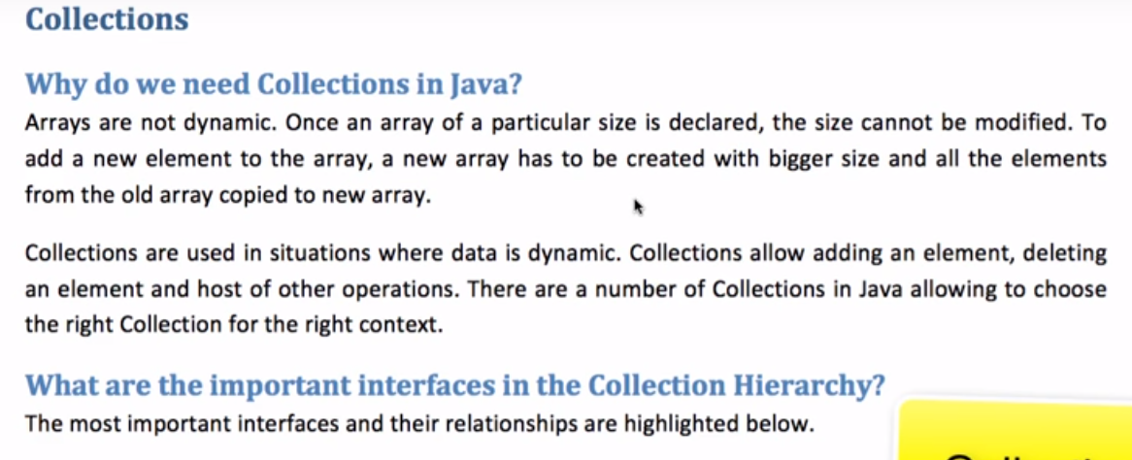

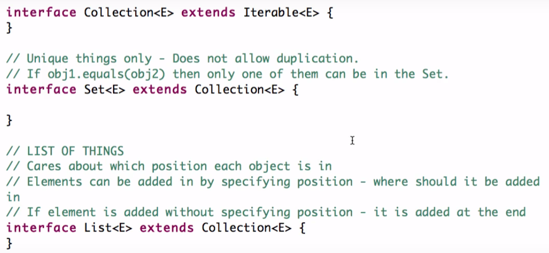

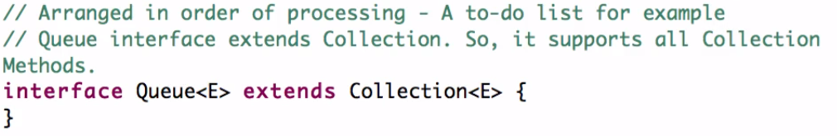

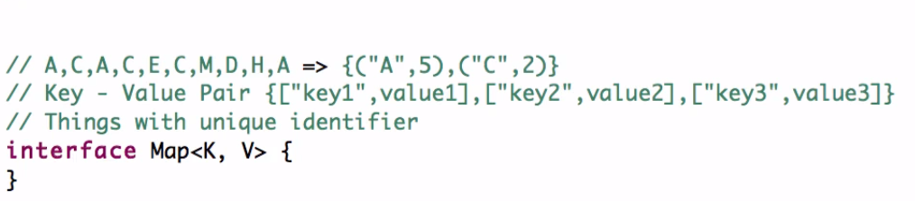

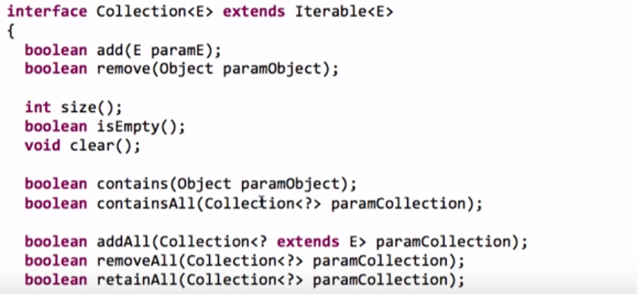

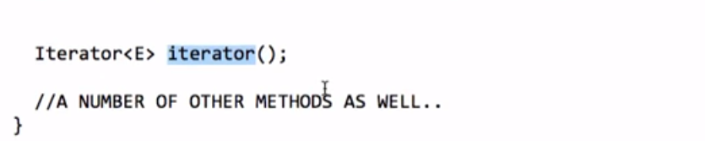

**public** **abstract** **interface** Iterable<T>

{

**public** **abstract** Iterator<T> iterator();

}

Note: In particular, c1.equals(c2)implies(kaa tatpary) that c1.hashCode()==c2.hashCode().

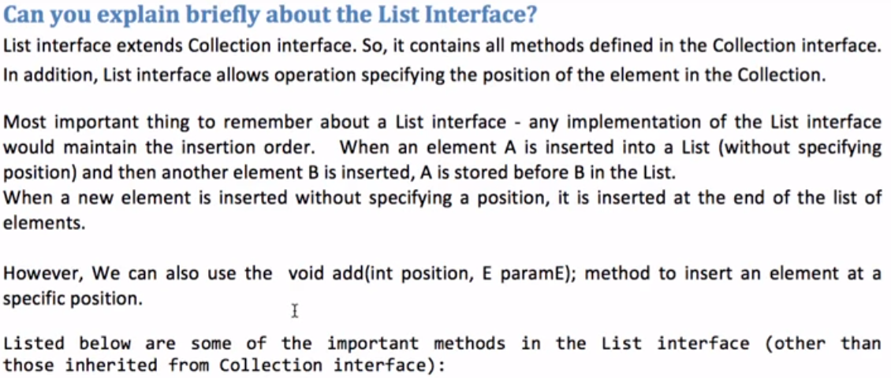

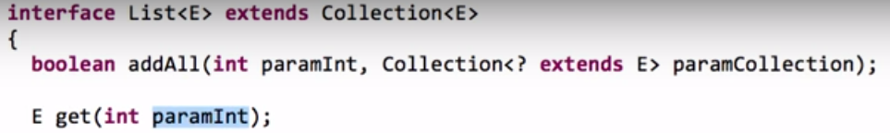

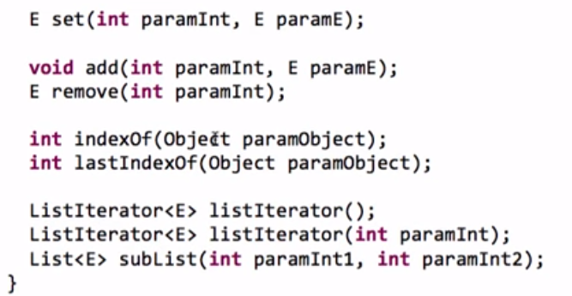

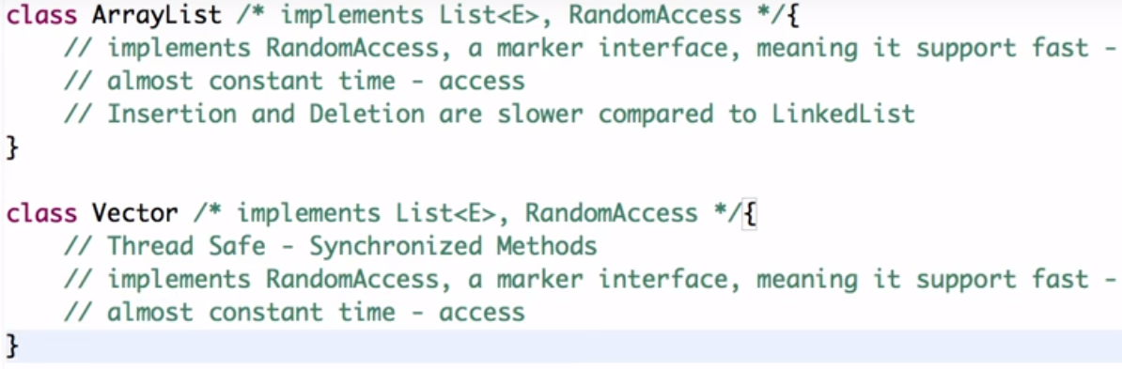

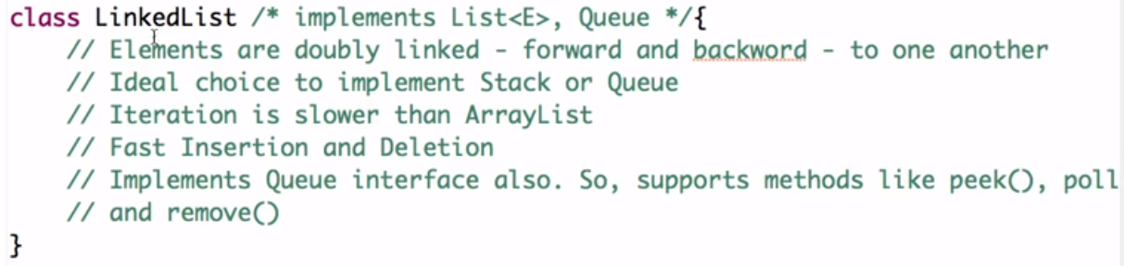

## Set Interface:-

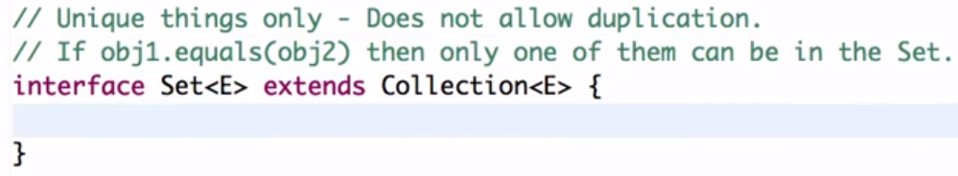

SortedsSet interface maintains order but Set interface does not maintains ordering.

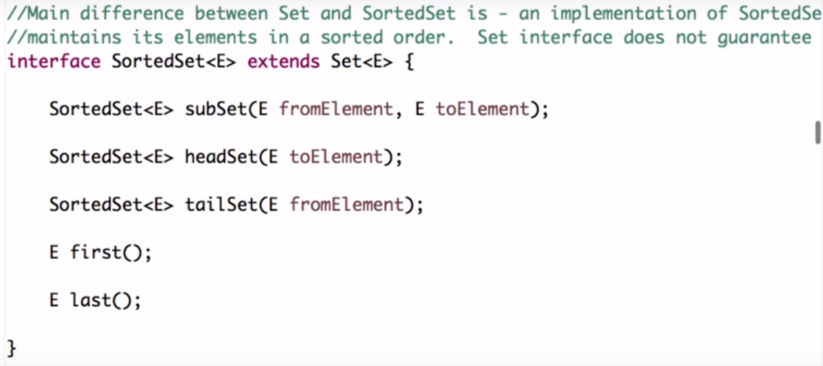

Navigate closest matches for a give search targets.

.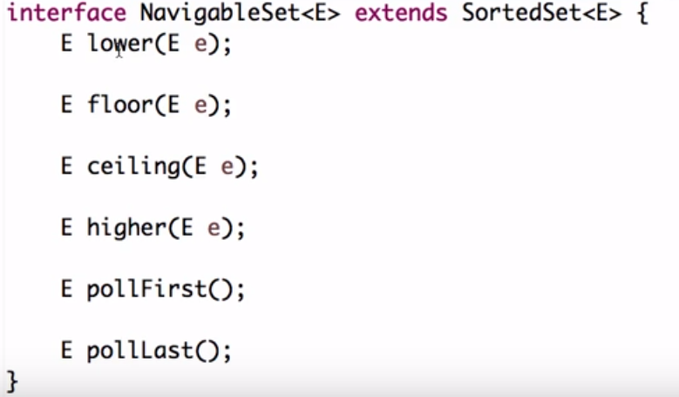

**HashSet**  is implementation of **Set** Interface which does not allow duplicate value all the methods which are in **Collection** **Framework** are also in Set Interface by default but when we are talking about Hash set the main thing is **objects which are going to be stored in HashSet must** [**override HYPERLINK "http://javarevisited.blogspot.com/2011/02/how-to-write-equals-method-in-java.html"equalsHYPERLINK "http://javarevisited.blogspot.com/2011/02/how-to-write-equals-method-in-java.html"()**](http://javarevisited.blogspot.com/2011/02/how-to-write-equals-method-in-java.html) **and hashCode() method** so that we can check for equality and no duplicate value are stored in our set.if we have created our own objects we need to implement **hashCode**() and **equal**() in such a manner that will be able to compare objects correctly when storing in a set so that duplicate objects are not stored,if we have not override this method objects will take default implementation of this method.

**public boolean add(Object o)**Method is used to add element in a set which returns false if it’s a duplicate value in case of  HashSet otherwise returns true if added successfully.

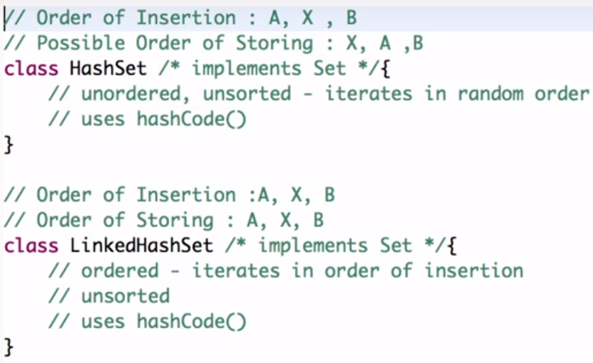

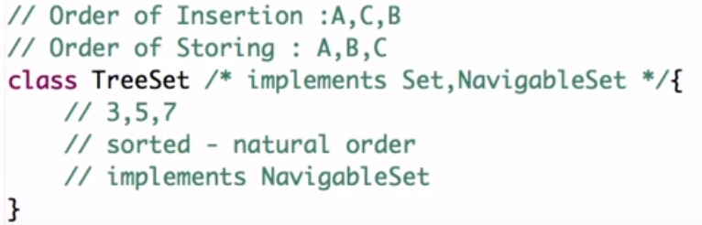

Queue Interface:-

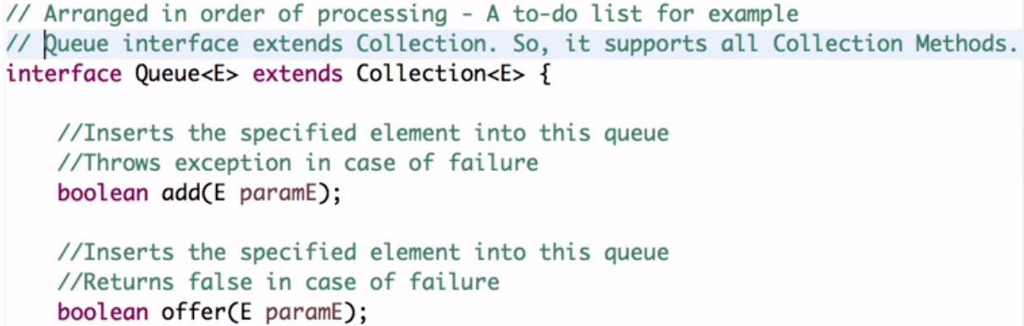

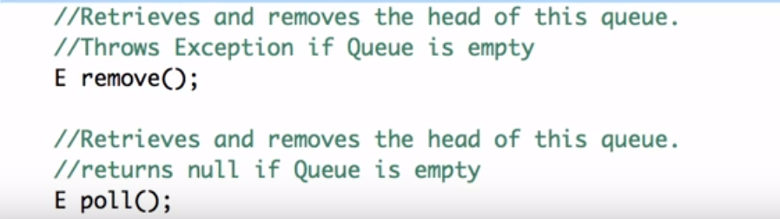

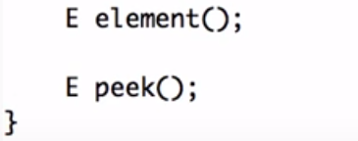

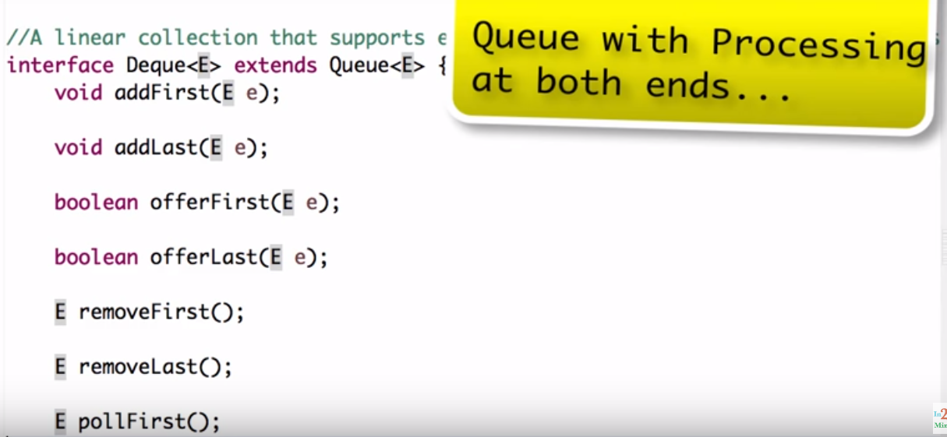

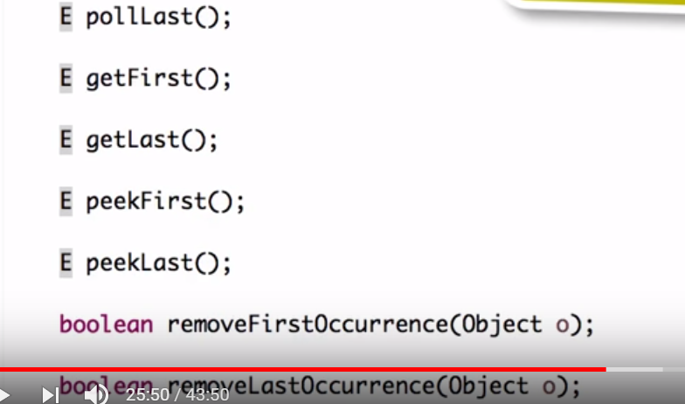

BlockingQueue Interface:-

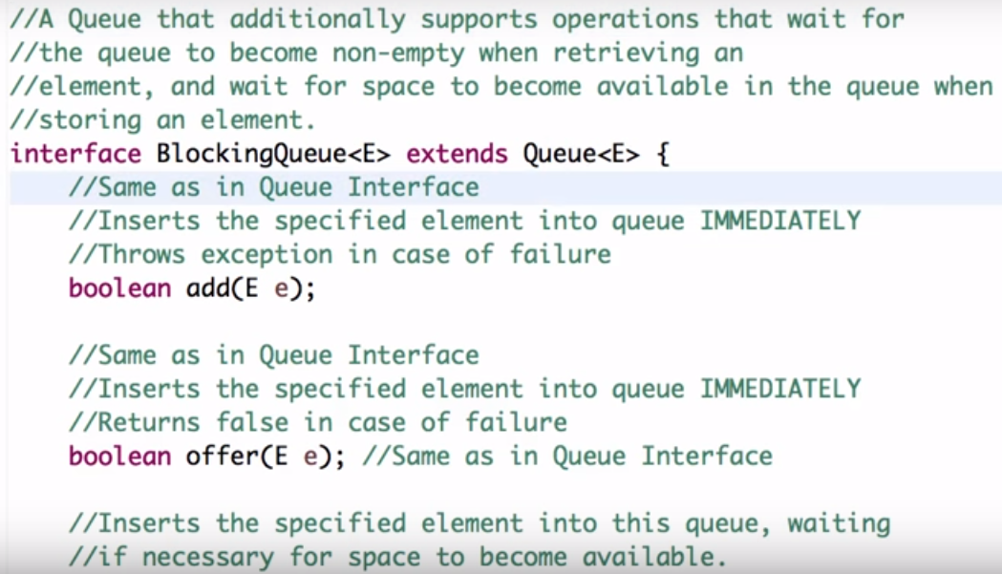

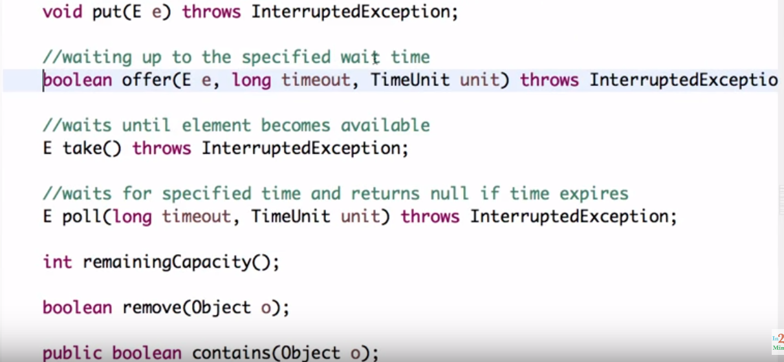

Classes of queue interface:-

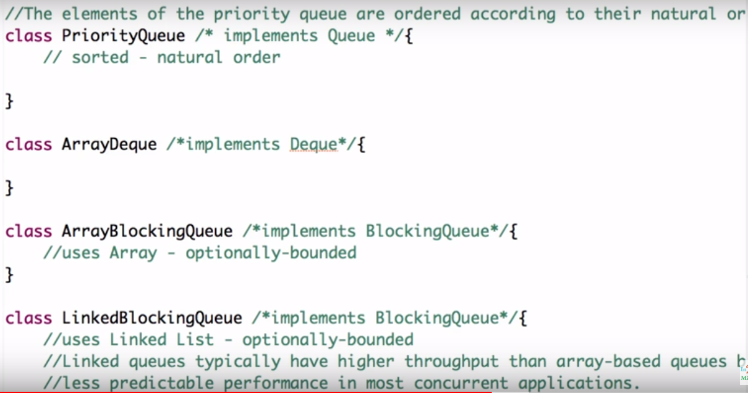

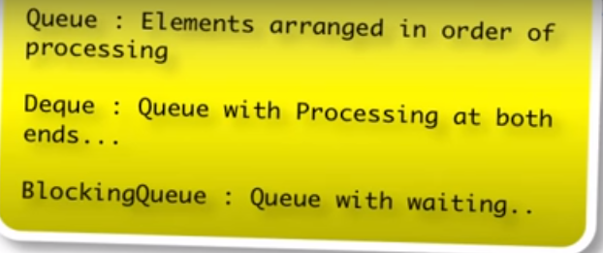

## Map Interface:

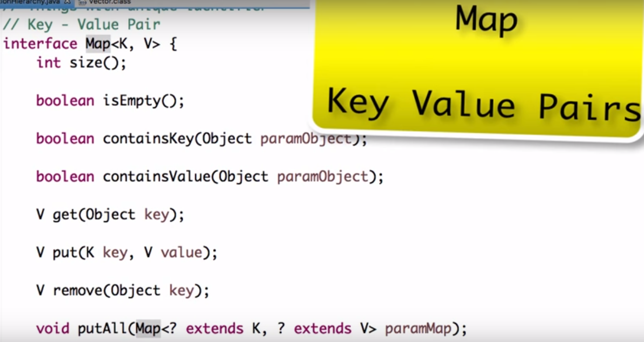

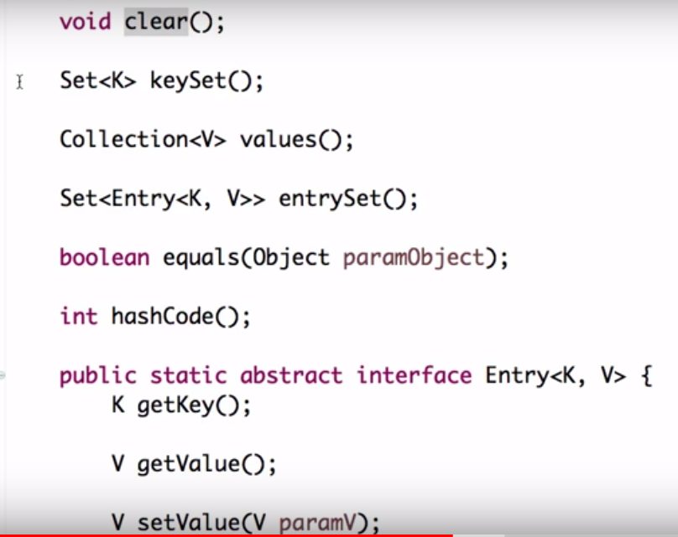

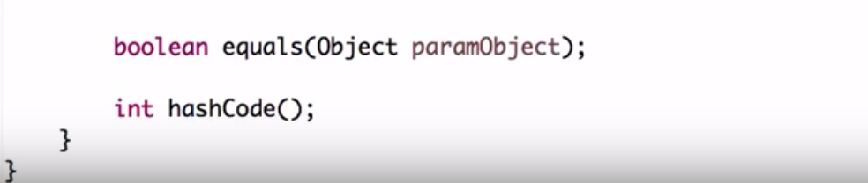

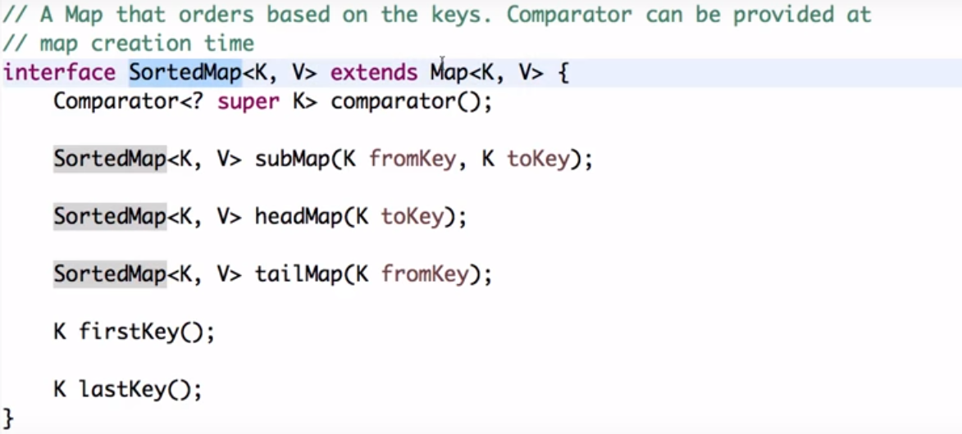

Navigate closest matches for a give search targets.

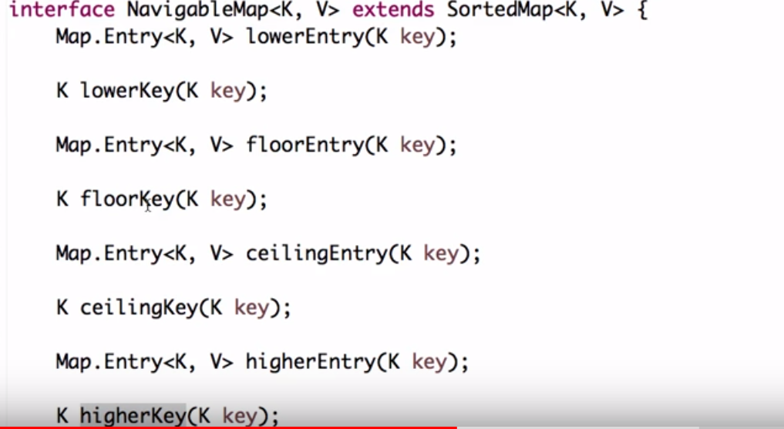

Classes for Map Interface:-

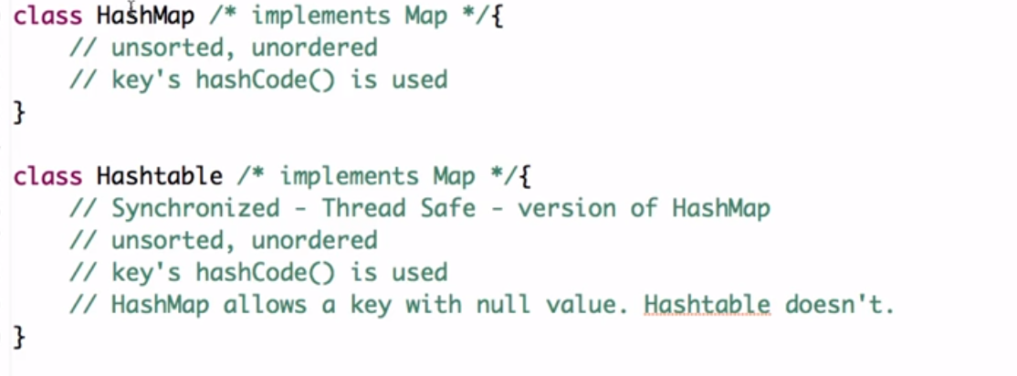

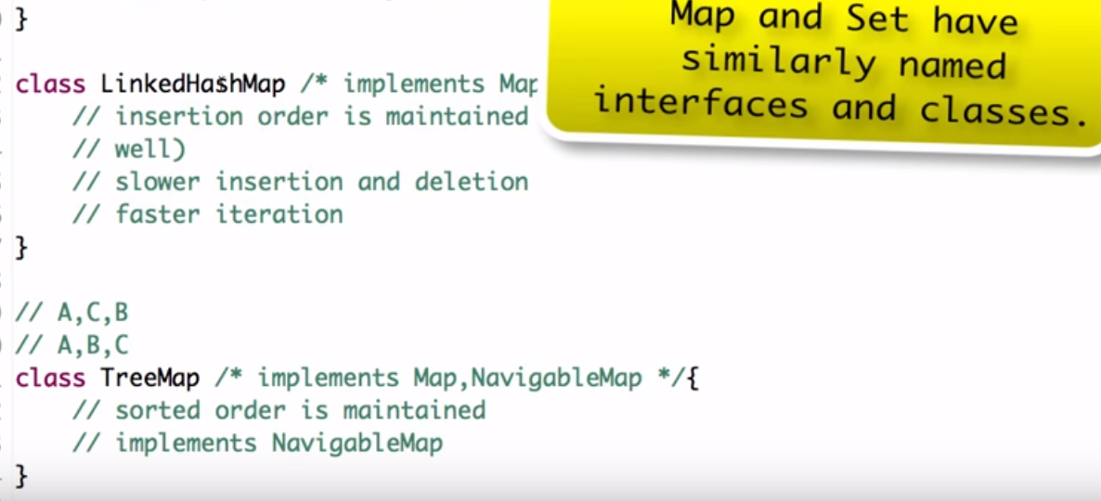

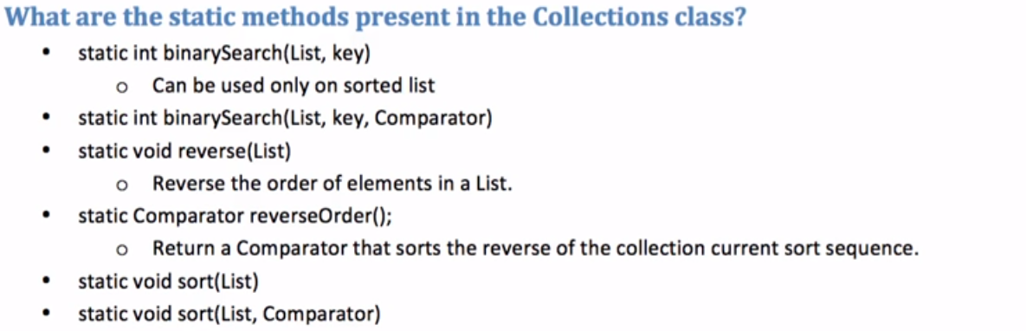

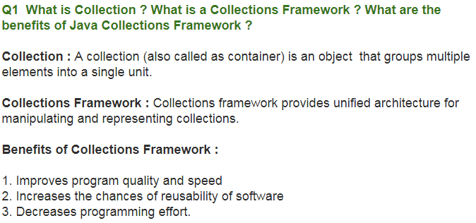

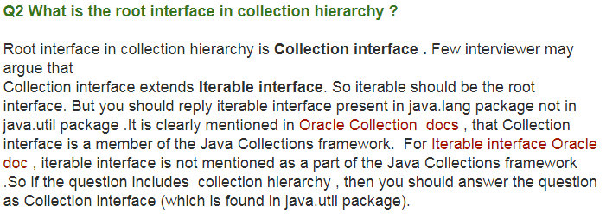

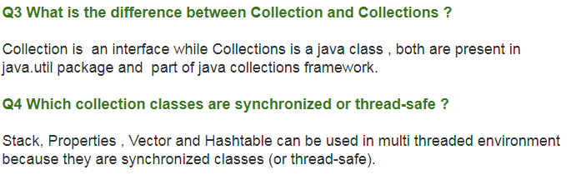

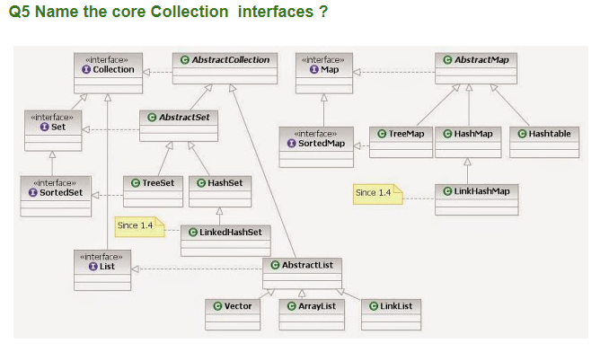

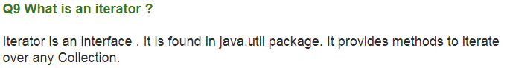

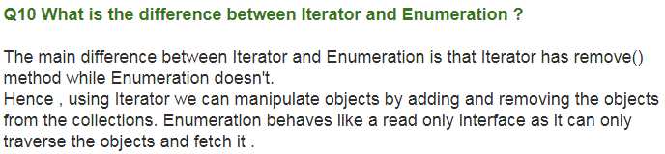

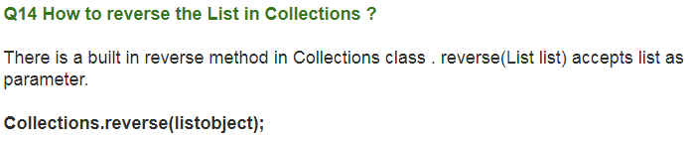

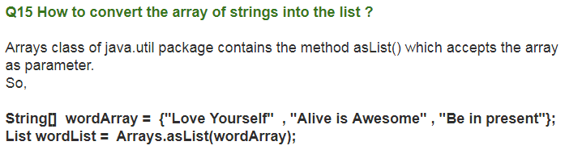

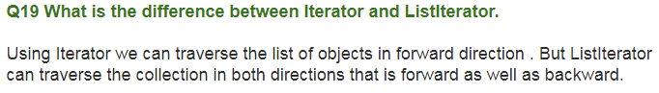

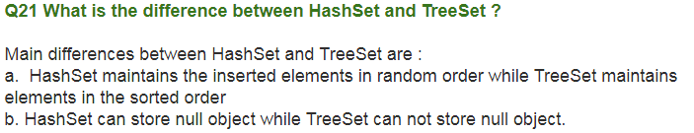

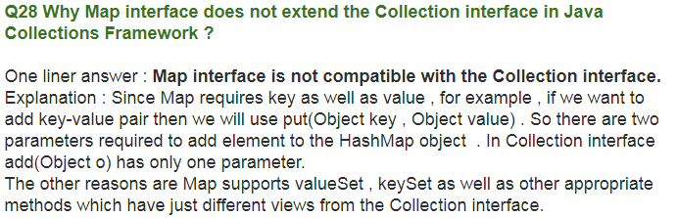

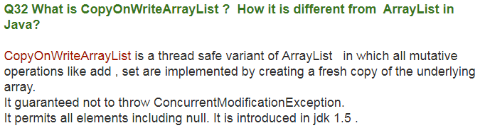

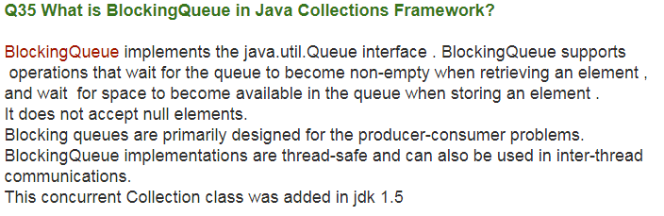

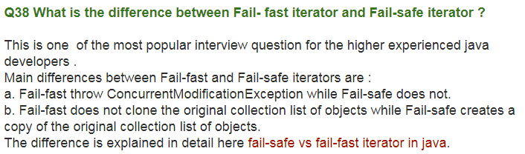

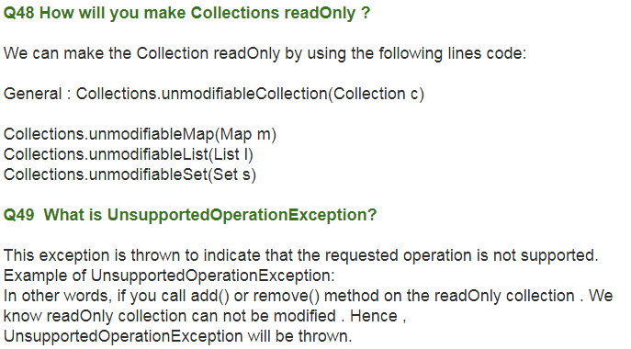

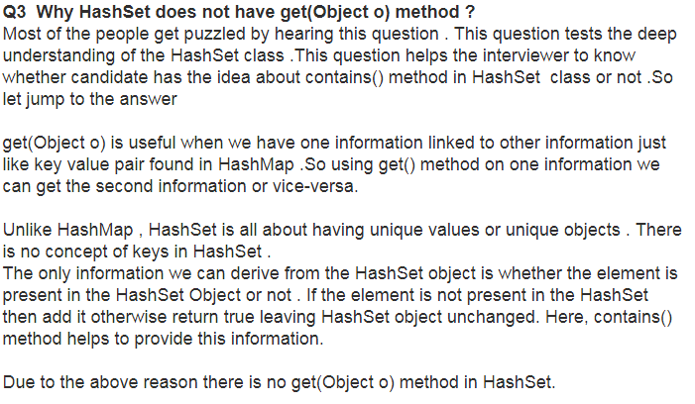

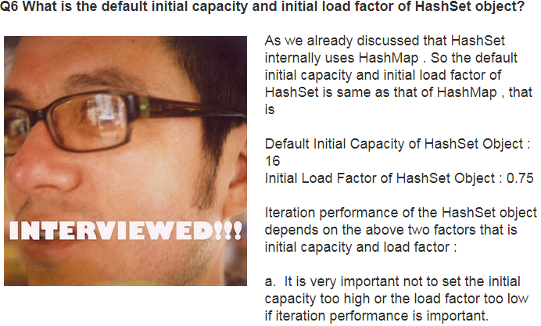

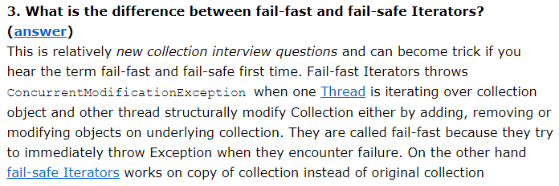

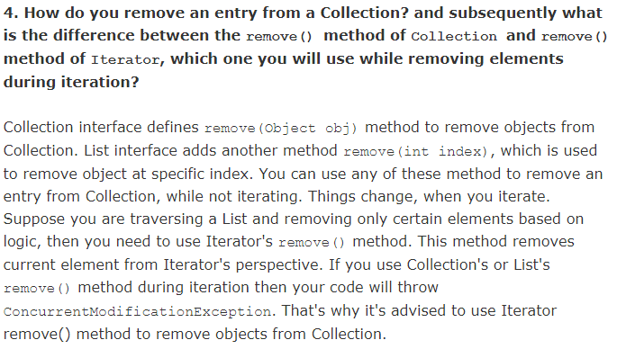

# **BlockingQueue:**A blocking queue is a queue that blocks when you try to dequeue from it and the queue is empty, or if you try to enqueue items to it and the queue is already full. A thread trying to dequeue from an empty queue is blocked until some other thread inserts an item into the queue. A thread trying to enqueue an item in a full queue is blocked until some other thread makes space in the queue, either by dequeuing one or more items or clearing the queue completely.

The java.util.concurrent package contains a set of synchronized Queue interfaces and classes. Blocking Queue extends Queue with operations that wait for the queue to become nonempty when retrieving an element and for space to become available in the queue when storing an element.

Here is a diagram showing two threads cooperating via a blocking queue:

|  |
| --- |
| A BlockingQueue with one thread putting into it, and another thread taking from it. |
| **A BlockingQueue with one thread putting into it, and another thread taking from it.** |

Following list of points about BlockingQueue in Java will help to learn and understand more about it:

1. BlockingQueue in Java doesn't allow null elements, various implementation of BlockingQueue like ArrayBlockingQueue, LinkedBlockingQueue throws [NullPointerException](http://javarevisited.blogspot.sg/2012/06/common-cause-of-javalangnullpointerexce.html) when you try to add null on queue.  
   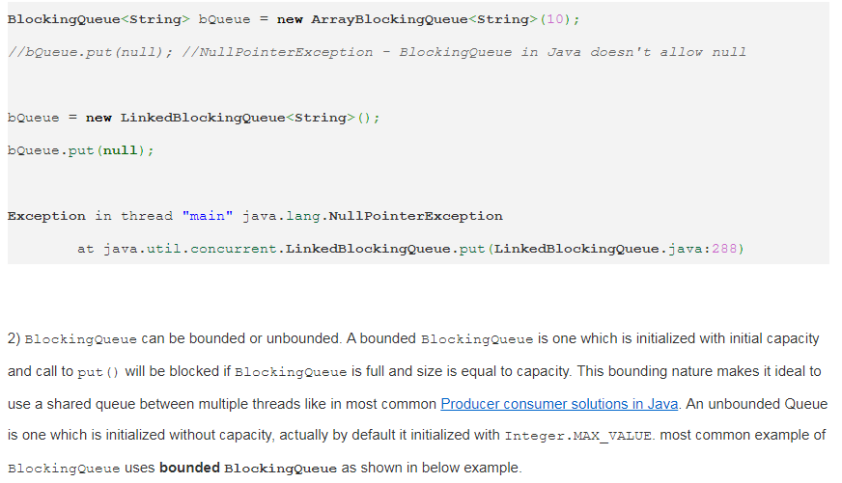

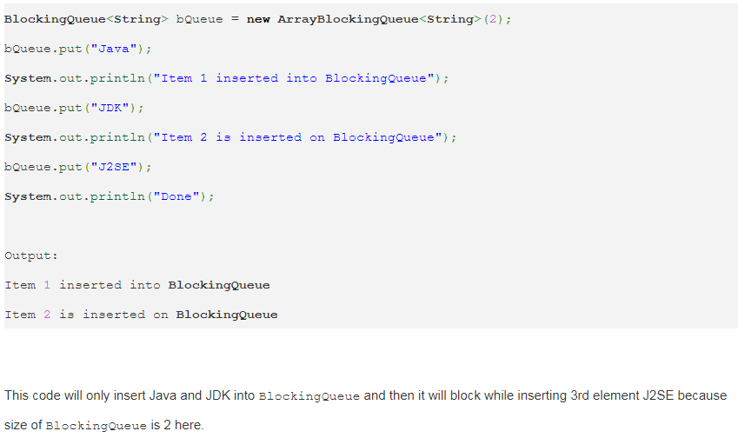

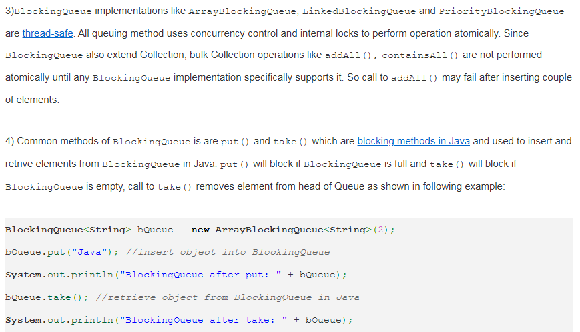

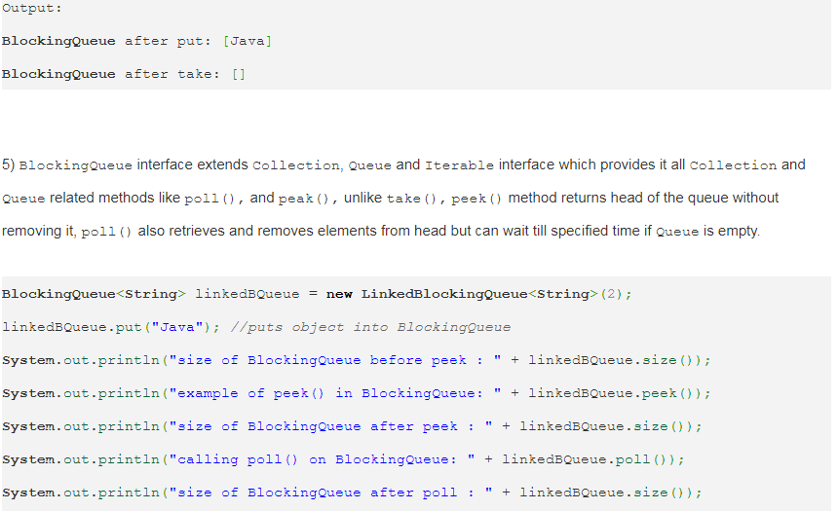

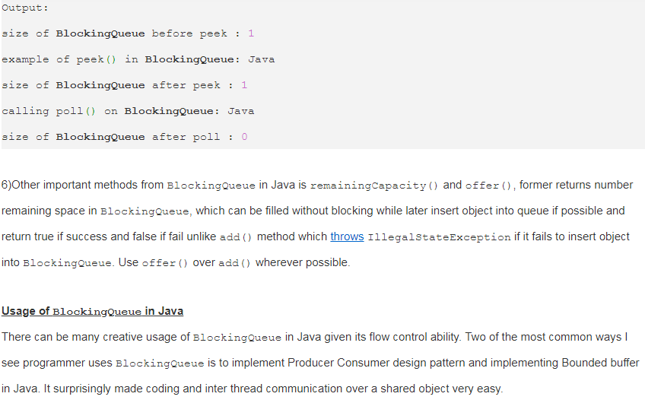

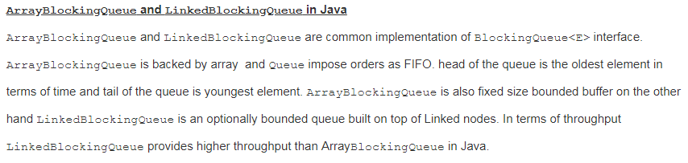

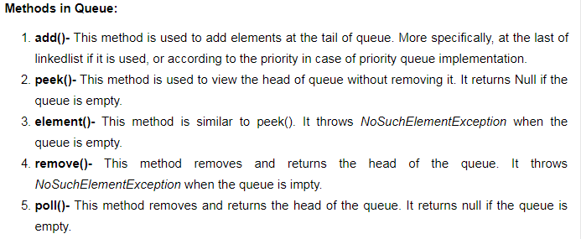

This interface is implemented by the following classes:

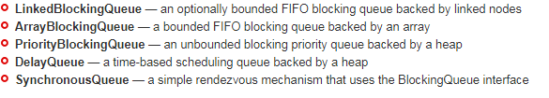

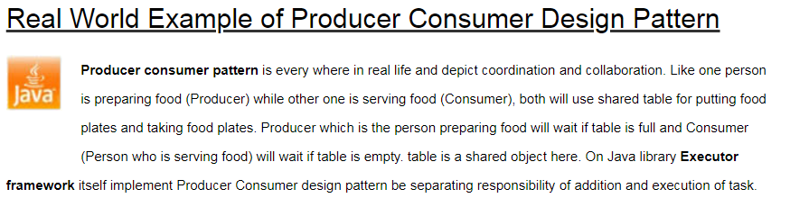

**Problem**  
To make sure that the producer won’t try to add data into the buffer if it’s full and that the consumer won’t try to remove data from an empty buffer.

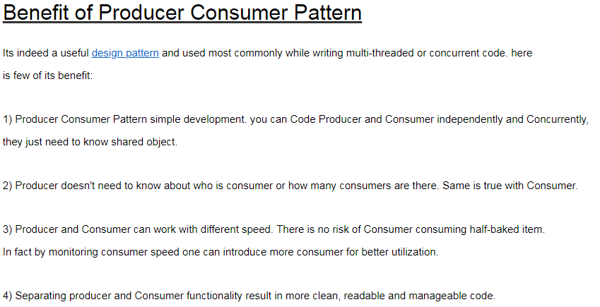

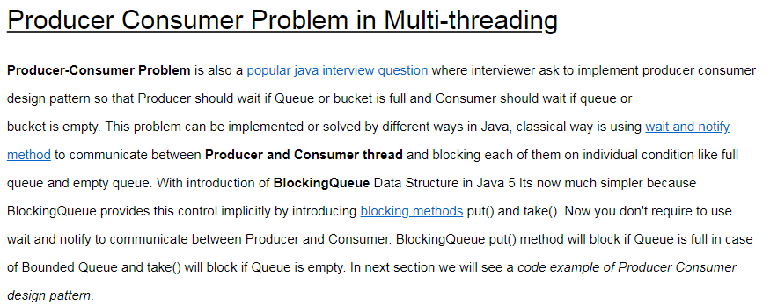

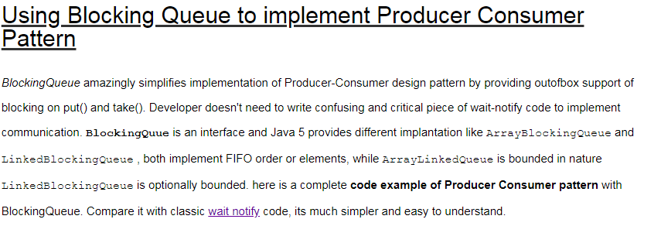

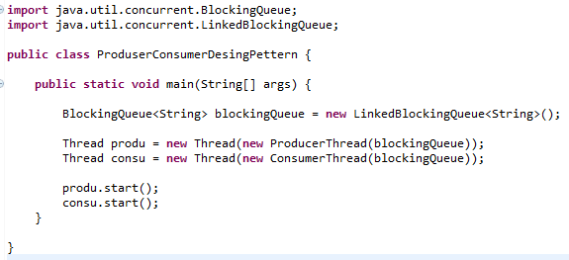

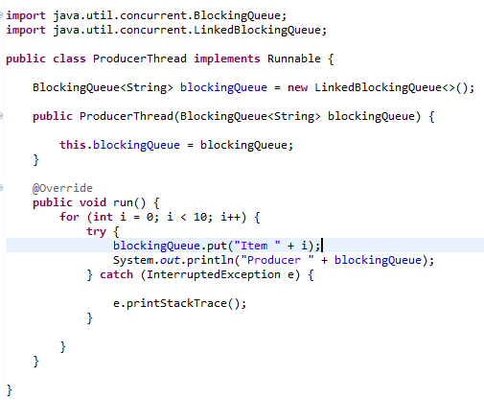

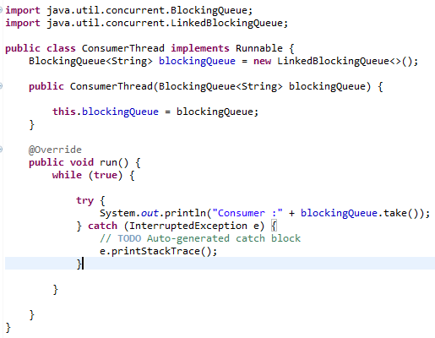

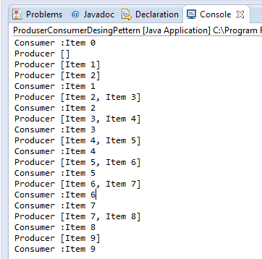

You see Producer Thread  produced number and Consumer thread consumes it in FIFO order because blocking queue allows elements to be accessed in FIFO.

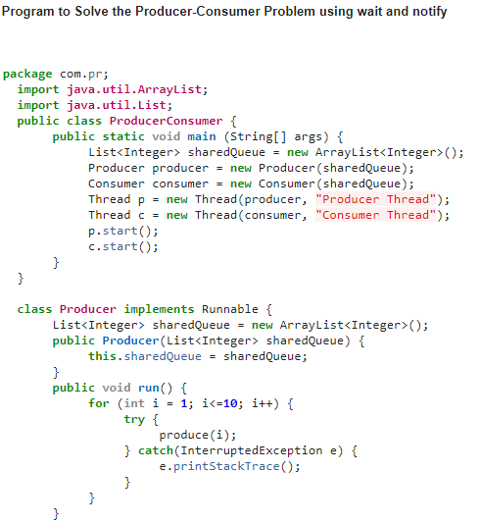

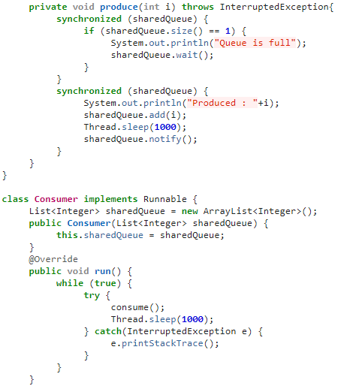

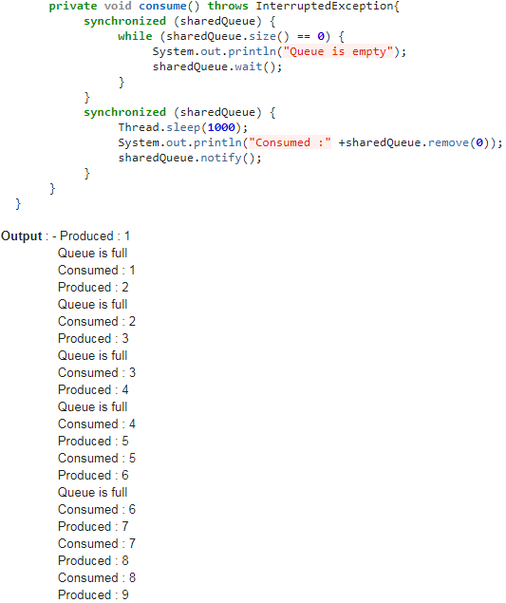

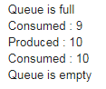

# What are differences between ArrayList and LinkedList in java?

